AUTOMATED NETWORK REQUEST MANAGEMENT IN SERVICENOW
Complete Project Documentation
ServiceNow – Service Portal, Flow Designer, Approvals, ACLs and Notifications
Project | Automated Network Request Management
Platform | ServiceNow
Primary Interface | Service Portal
Workflow | Catalog → Records → Approval → Task  → Status → Notification


The project focuses on developing an automated Network Request Management system using ServiceNow.
The main purpose is to provide users with a simple and structured way to submit network-related service requests and automate the complete process from request submission to approval, task creation, fulfilment, and notification.
The system uses Service Catalog, Catalog Item, Catalog Variables, Flow Designer, Approvals, Network Task, Business Rules, Notifications, Access Controls, and Update Sets to manage the network request lifecycle.
Instead of processing network requests manually, the configured workflow automatically moves the request through the required stages and keeps the concerned users informed about its progress.

Project Workflow
The implemented process follows this sequence:
- User opens the Network Request catalog item through the Service Portal.
- User enters the required network request details such as Email ID, Phone Number, Device Type, Connection Type, Address, Device Details, and other required information.
- The system validates the mandatory fields before submission.
- The Requested For field is automatically populated with the current user.
- User submits the request using Order Now.
- ServiceNow creates the corresponding Request and Requested Item (RITM) records.
- The configured Flow Designer flow retrieves the catalog variables and creates the required database record.
- The request is routed through the configured approval process.
- Once the request is approved, the workflow creates a Network Task for fulfilment.
- Notifications are generated at the required stages to inform the concerned users.
- The Network Task is processed and the request status is updated.
- The completed request can be tracked through ServiceNow.

Project Phases
The project was implemented through the following phases:
- Requirement Analysis & Planning – Understanding the network request process, identifying stakeholders, defining the required request information, and planning the implementation roadmap.
- Backend Development & Configuration – Creating the Network Request catalog item, configuring catalog variables, designing the network database structure, and configuring the approval request process.
- UI/UX Development & Customization – Designing the Network Request interface, configuring the Service Portal form, establishing navigation flow, improving usability, and applying required business rules.
- Data Migration, Testing & Security – Configuring automation, access controls, performing QA testing, validating mandatory fields and auto-population, and ensuring data integrity.
- Deployment, Documentation & Final Presentation – Performing troubleshooting, maintaining timelines, preparing functional and technical documentation, creating the setup manual, demonstrating the working system, and defining scalability and future improvements.

Final Outcome
The completed system provides a structured and automated method for handling network service requests.
The main outcome is a connected workflow where the request submission, data capture, validation, approval, Network Task creation, fulfilment, status update, and notification are managed within ServiceNow.
The project was tested using actual ServiceNow records, catalog forms, approval records, Flow Designer execution, and Network Task outputs. The screenshots included in the following sections provide evidence for the configuration steps and their corresponding results.

2. Phase 1 – Requirement Analysis & Planning
Step 1: Understand the Project Requirement
- Identify the problem: network service requests require a structured and automated process.
- Decide to automate the request lifecycle using ServiceNow.
- Define the main objective of the system.
- Identify the information that users need to provide while submitting a network request.
- Define the overall process:
Request → Validation → Approval → Network Task → Fulfilment → Status Update → Notification
Step 2: Define the ServiceNow Components
Decide what ServiceNow components are required for the implementation:
- Service Catalog
- Network Request Catalog Item
- Catalog Variables
- Network Database Table
- Flow Designer
- Approval Request
- Network Task
- Catalog Client Script
- Business Rules
- Notifications
- Access Controls
- Update Sets
These components are planned during the requirement stage and configured in the later implementation phases.
Step 3: Identify Stakeholders
Define the users and teams involved in the network request lifecycle:
- Requester / End User
- Manager / Approver
- Network Fulfilment Team
- ServiceNow Administrator

Requester
Submits the Network Request through the Service Portal and provides the required information.

Manager / Approver
Reviews the request and provides the required approval before fulfilment.

Processes the generated Network Task and performs the required network-related activity.

ServiceNow Administrator
Configures the catalog item, variables, workflows, business rules, access controls, notifications, and other ServiceNow components.

Step 4: Define the Functional Scope
The functional scope of the project includes:
- Creation of the Network Request Service Catalog item.
- Configuration of request variables.
- Validation of mandatory information.
- Automatic population of the Requested For field.
- Creation of the required database records.
- Configuration of approval requests.
- Automated creation of Network Tasks.
- Sending email notifications.
- Updating request/task status.
- Applying access controls.
- Testing the complete request lifecycle.
- Maintaining data integrity.
The overall scope is to automate the network request process from initial submission to fulfilment and notification.

Step 5: Prepare the Project Roadmap
The implementation is planned in the following sequence:
Requirement Analysis → Backend Configuration → UI/UX Customization →
Automation & Security → Testing → Documentation & Deployment
The detailed project roadmap is divided into five phases:
Phase 1: Requirement Analysis & Planning
↓
Phase 2: Backend Development & Configurations
↓
Phase 3: UI/UX Development & Customization
↓
Phase 4: Data Migration, Testing & Security
↓
Phase 5: Deployment, Documentation & Final Presentation
This roadmap provides a structured approach for implementing and validating the complete Automated Network Request Management system in ServiceNow.

3. Phase 2 – Backend Development & Configurations
Phase 2 established the backend structure for Network Requests, Network Database records, Network Tasks and approval handling.
3.1 Data Architecture
Custom tables were used to organize the request and task data. The Network Database table stores structured request information, while the Network Task table represents the work generated for the Network Team.
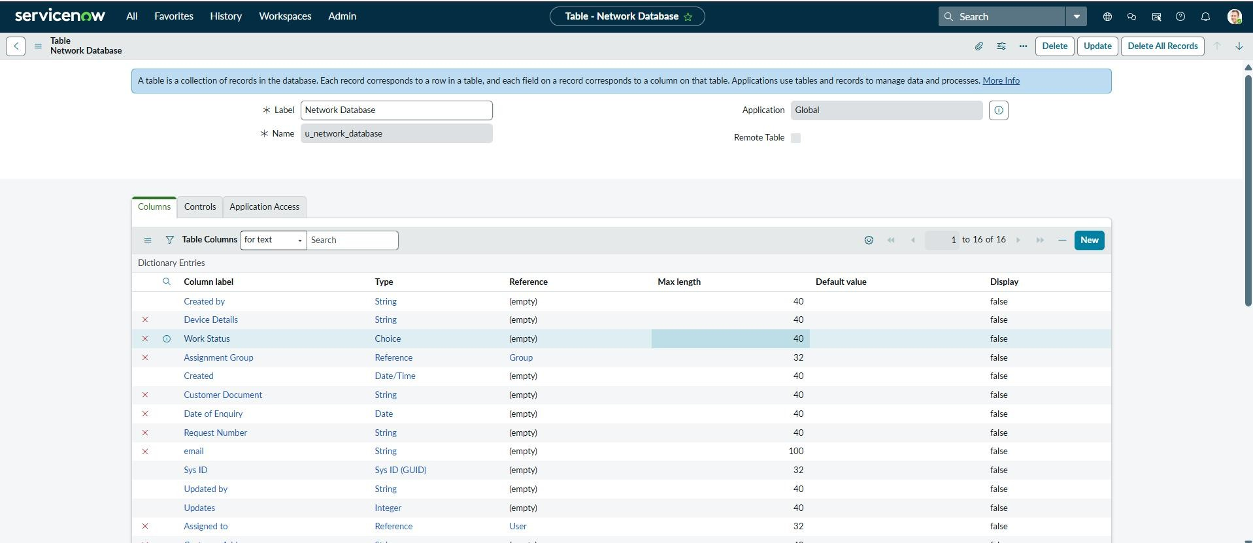
Figure 3.1 – Network Database table/list configuration
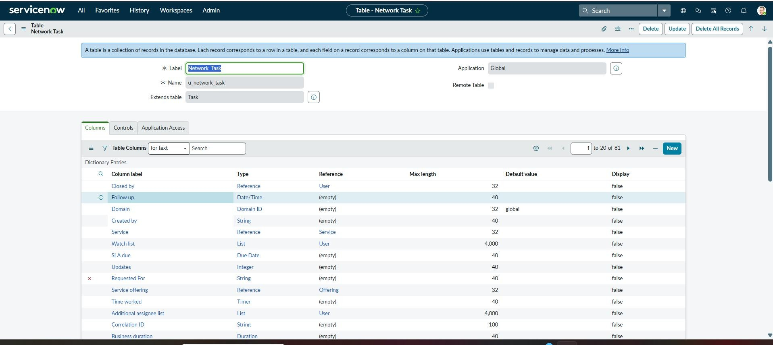
Figure 3.2 – Network Task records and related information

3.2 Network Task
The Network Task record is generated as part of the automated request lifecycle. It carries the operational task information required by the Network Team and supports subsequent status updates.
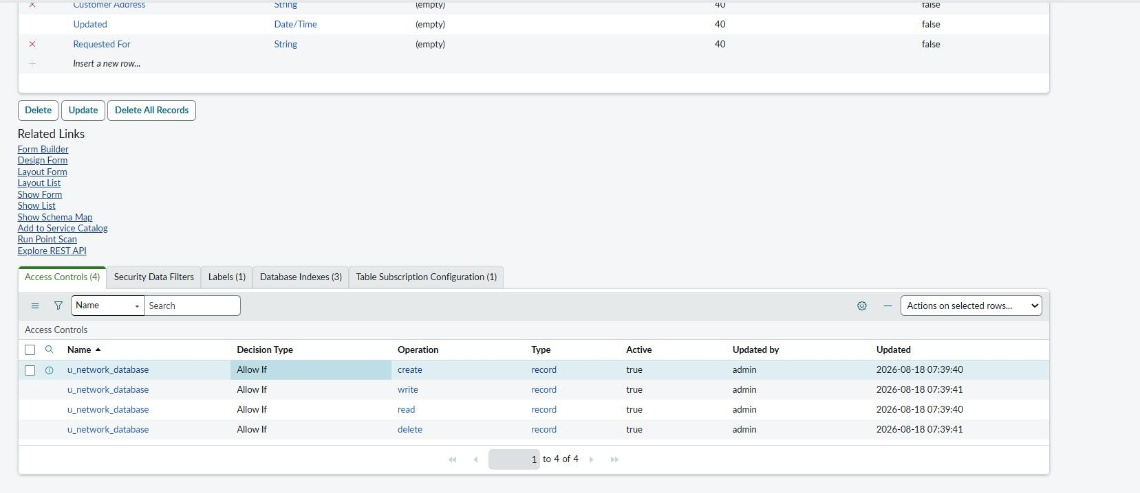
Figure 3.3 – Network Task record/output
3.3 Approval Request
An Approval Request relationship was configured so that approval information can be displayed against the Network Database record. The relationship connects the request record with approval records and provides an Approval Request related list.
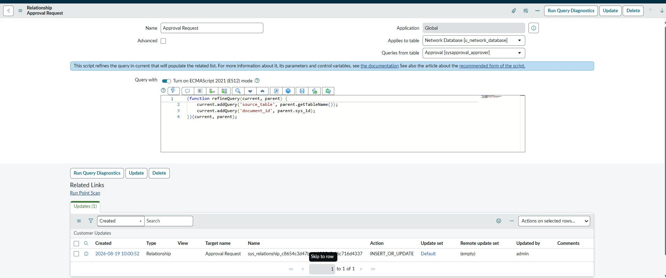
Figure 3.4 – Approval Request relationship configuration
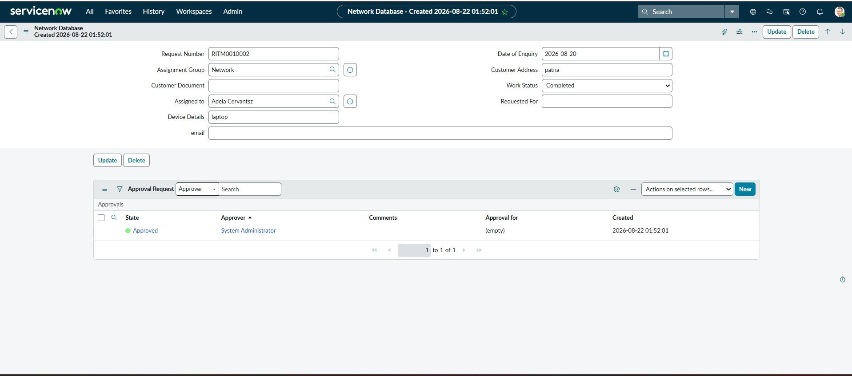
Figure 3.5 – Approval Request related-list output

3.4 Approval Output
The approval output confirms that an approval record is generated and can reach an Approved state with an approver associated with the request.
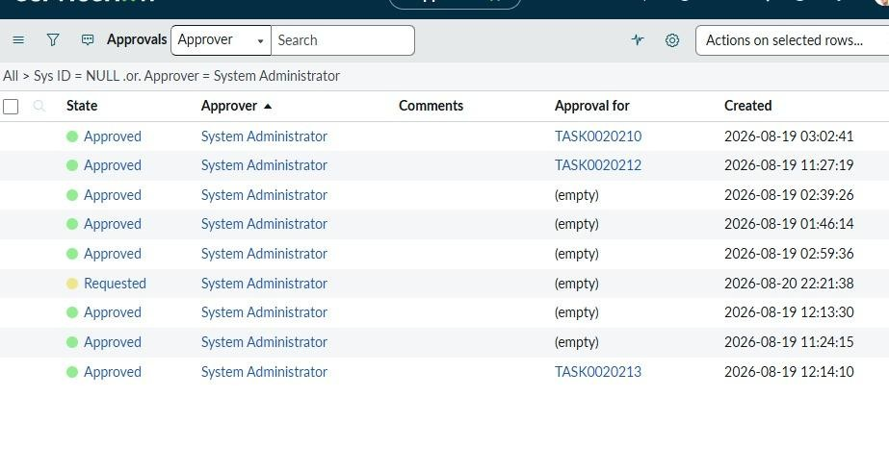
Figure 3.6 – Approval records showing approval state and approver
- Phase 3 – UI/UX Development & Customization
Phase 3 focused on creating a user-friendly Service Portal experience for Network Request submission, defining the navigation path, improving usability and applying business/UI logic.
4.1 Interface Design
Objective:
To design a user-friendly Network Request interface in ServiceNow Service Portal using catalog items, variables, and variable sets.
Activity 1: Creation of Service Catalog
Navigation:
ServiceNow → Service Catalog → Catalog Definitions → Maintain Items
  - Click New.
  - Create the Network Request catalog item.
  - Enter the required details and save.
Output: Network Request catalog item created successfully.
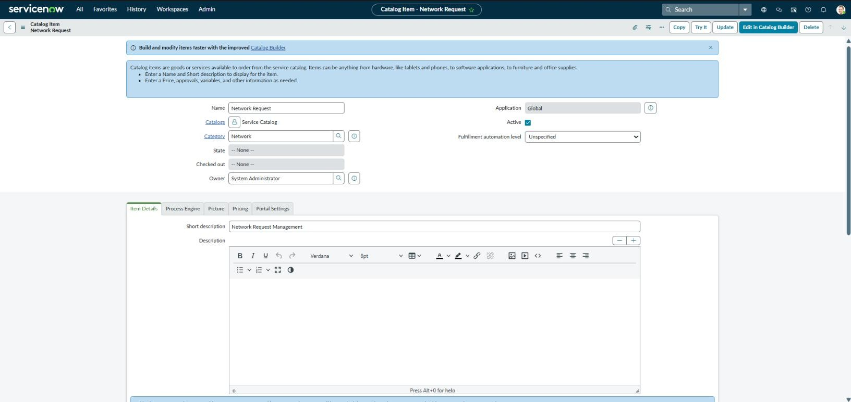
fig 3.1- Creation of Service Catalog:
Activity 2: Variables Configuration
Navigation:
Network Request → Variables
  - Open the Network Request catalog item.
  - Configure the required variables.
  - Set mandatory fields and display order.
  - Save the configuration.
Output: Required variables configured for the request form.
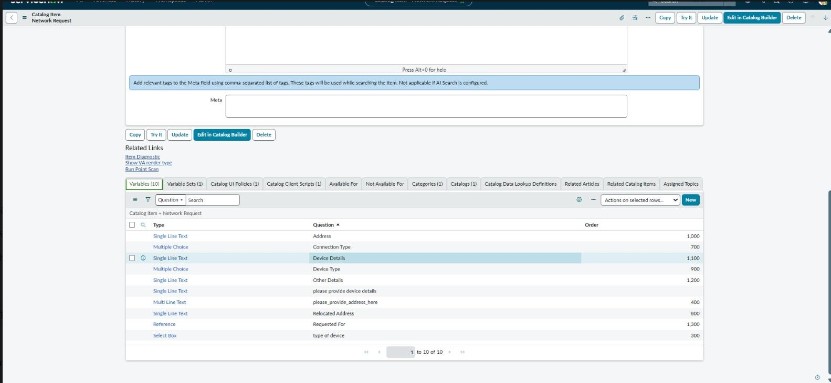
Fig 3.2- Variables Configuration
Activity 3: Variables Creation
Navigation:
Network Request → Variables → New
  - Create the required variables.
  - Configure appropriate variable types.
  - Add choices where required, such as Laptop, Mobiles, Others.
  - Save the variables.
Output: Network Request input fields created successfully.
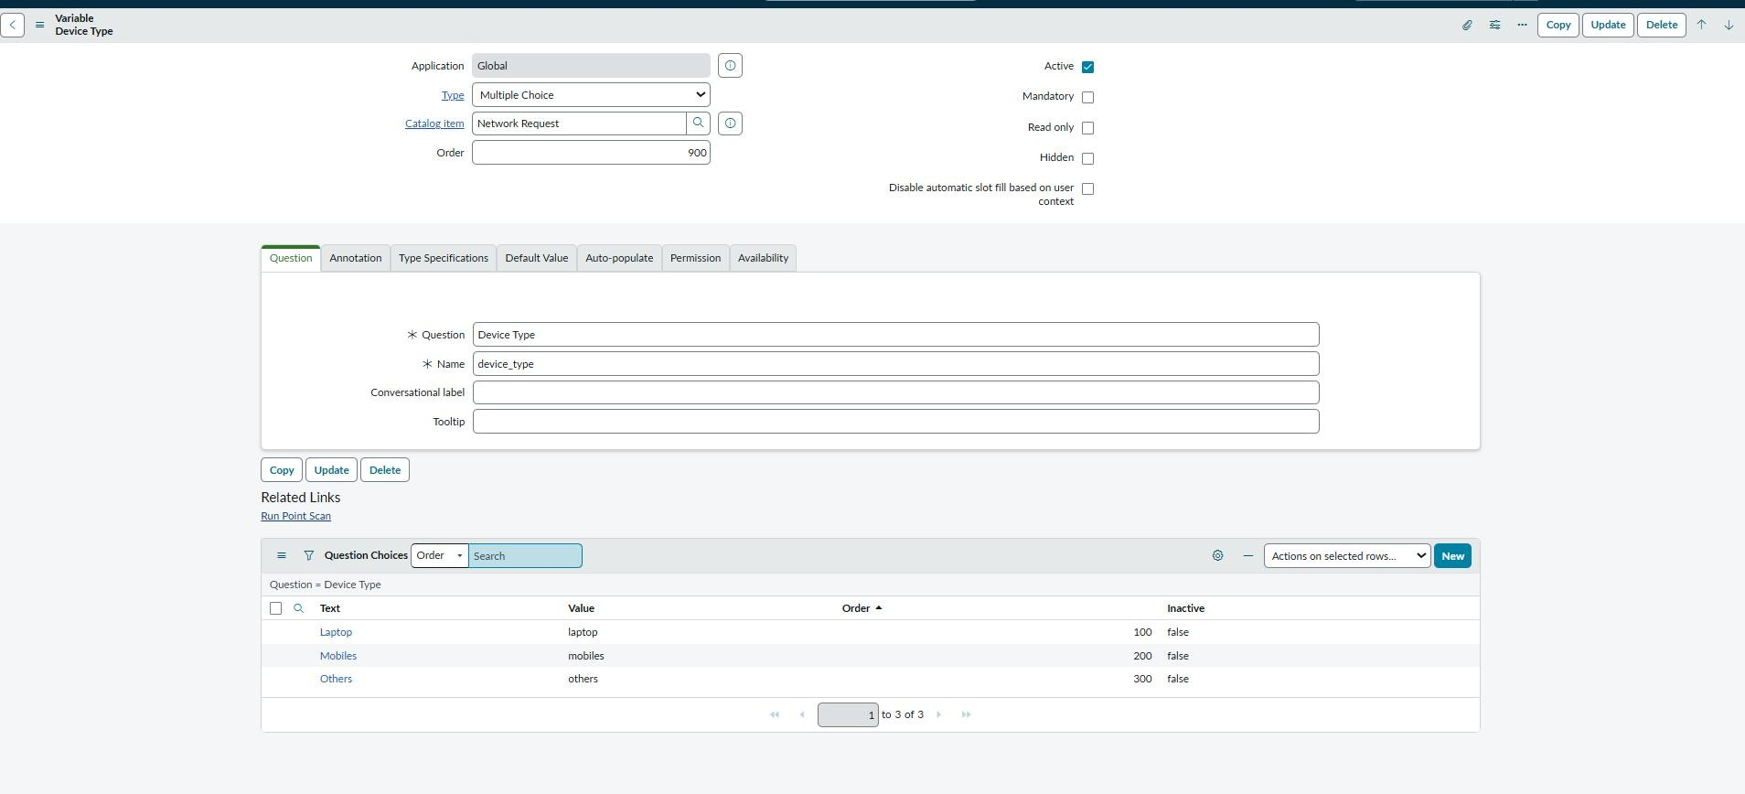
fig 3.3-Variables Creation
Activity 4: Variable Set Configuration Navigation:
Service Catalog → Variable Sets
  - Create the required Variable Set.
  - Add the related variables.
  - Associate it with the Network Request catalog item.
  - Save.
Output: Variables organized using the configured Variable Set.
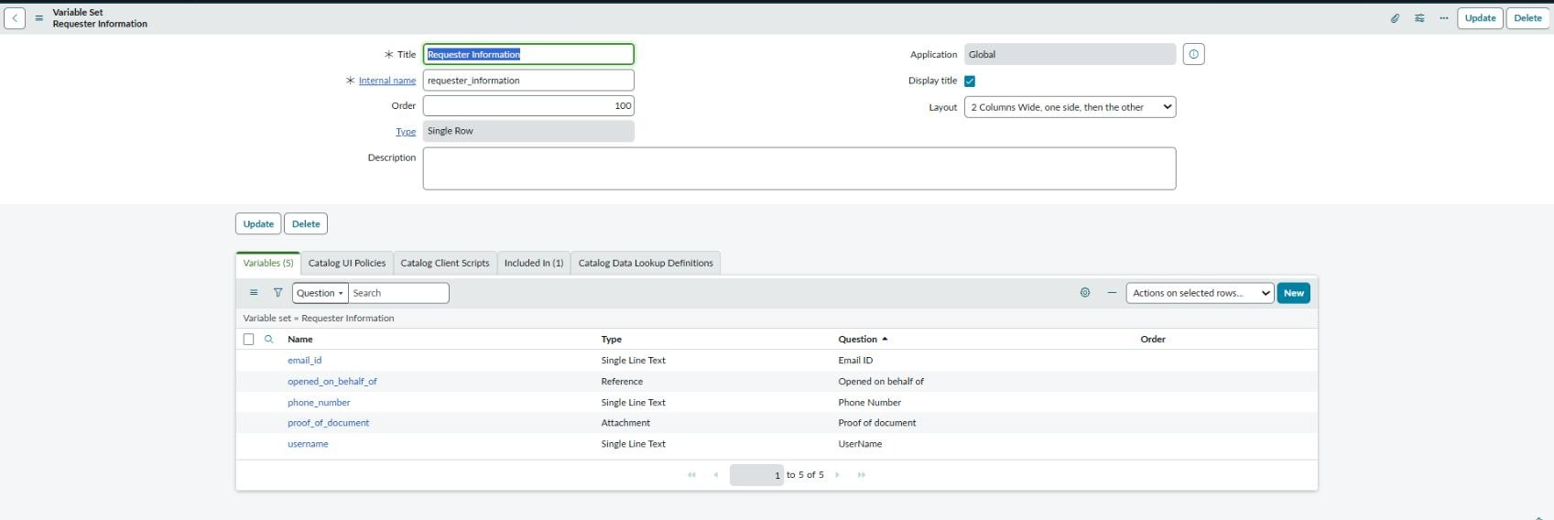
3.4Variable Set Configuration
Final Output:The Network Request interface is successfully configured with structured fields, selection options, mandatory inputs, and a user-friendly Service Portal layout.

4.2 Navigation Flow
The user navigates from the ServiceNow portal to the Network Request catalog item, enters the required information and submits the request. A request number is generated and the workflow continues with automated processing and notifications.
- Log in to the ServiceNow portal.
- Open the Service Portal and search for Network Requests.
- Open the Network Request catalog item.
- Fill the required details.
- Submit the request.
- Use the generated request number to track the request and receive notifications.
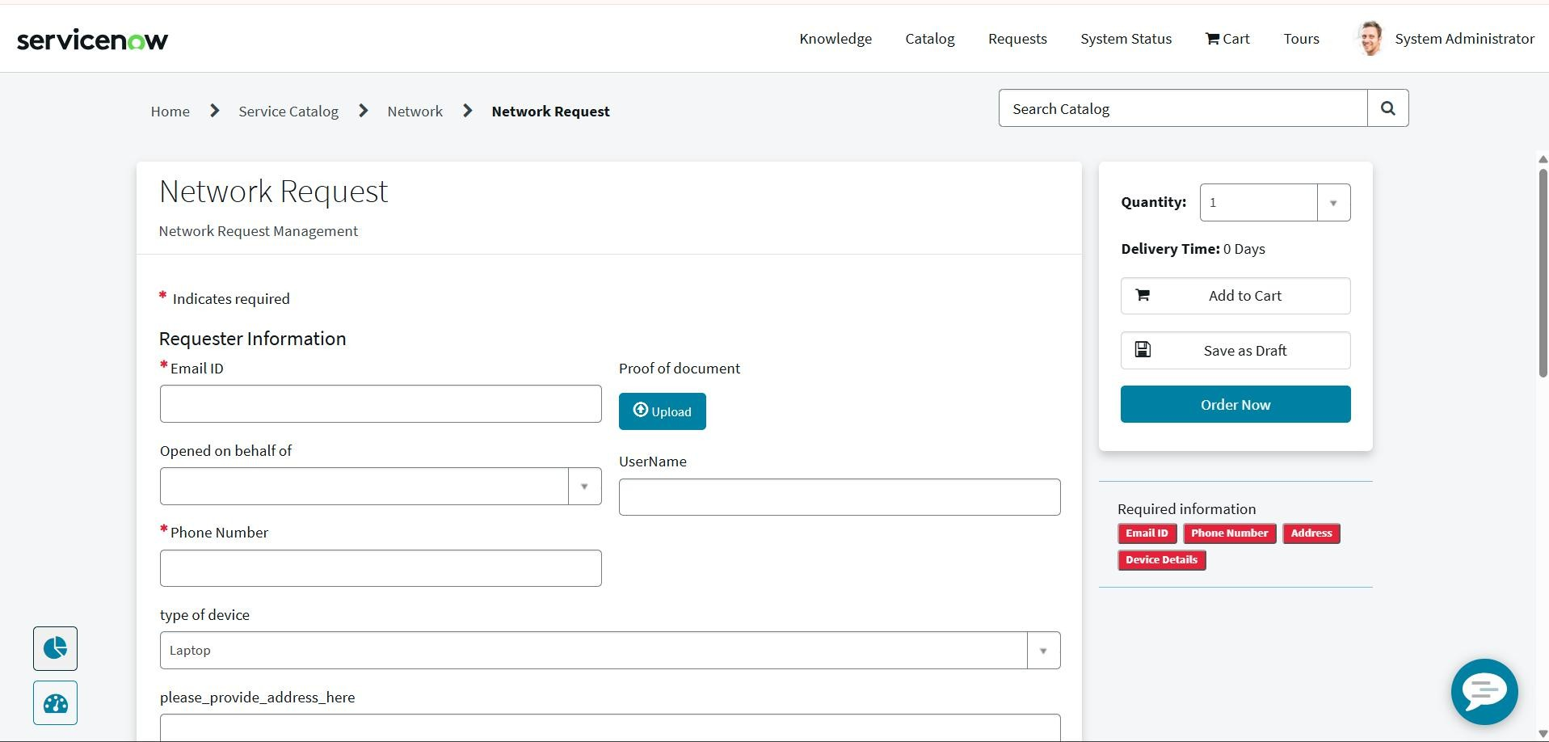
  - Usability
The interface groups related information into a single request form and provides visible mandatory-field indicators, submission controls, Requested For information and attachment support.
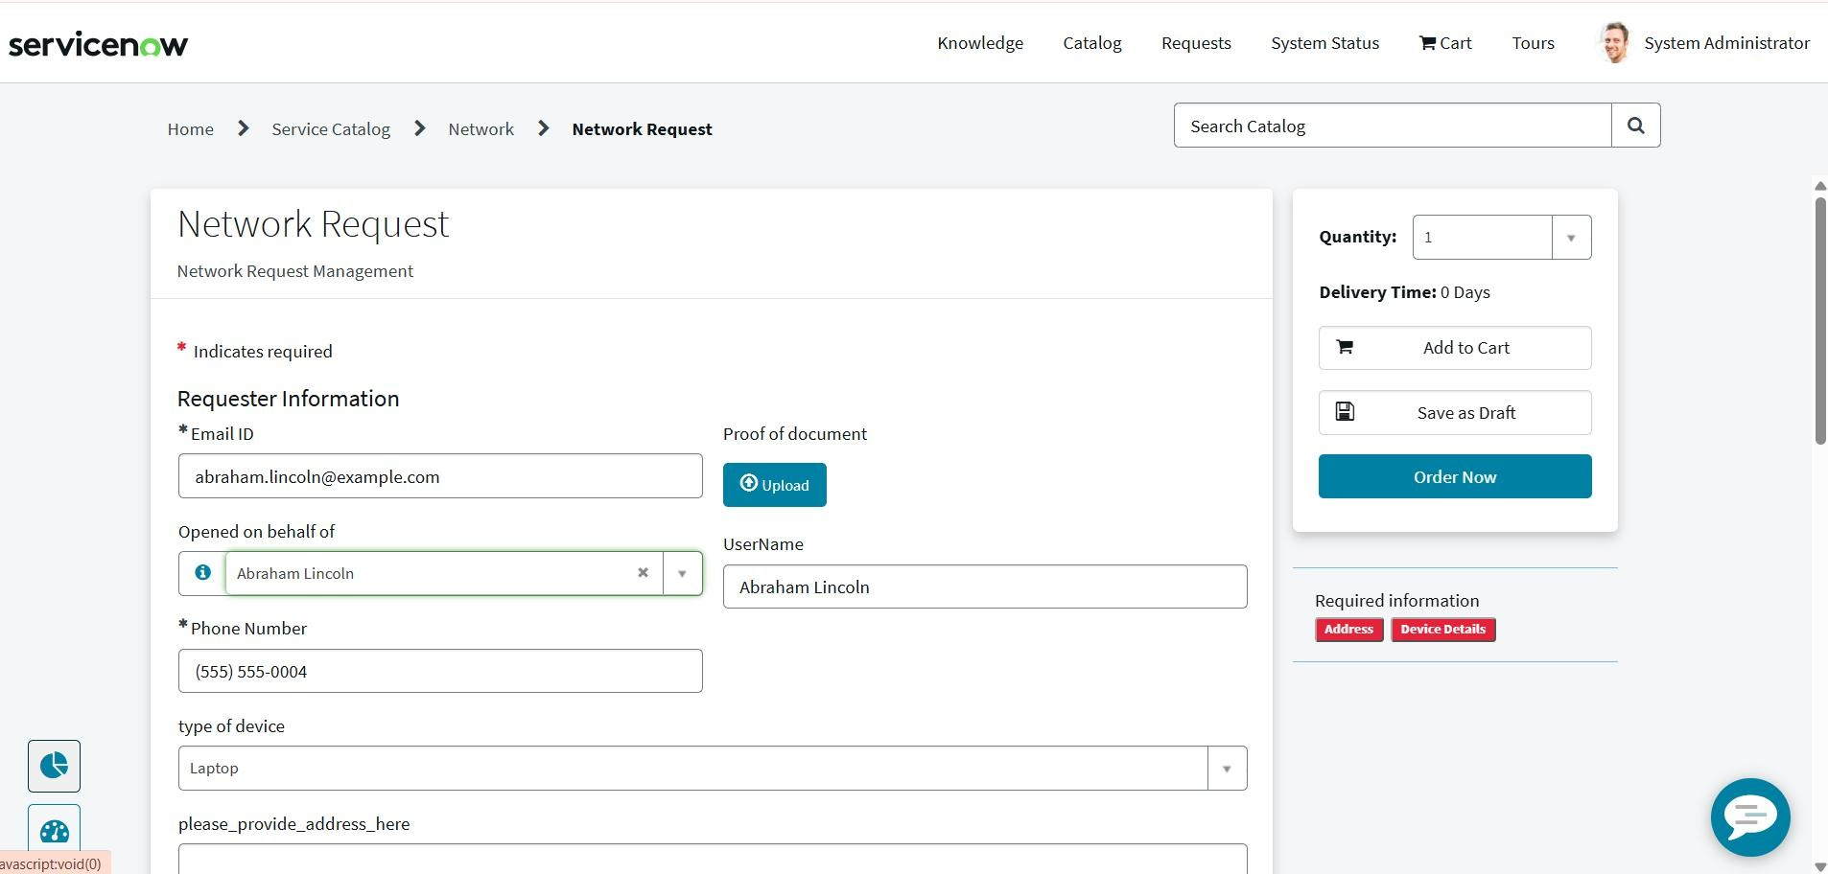
Figure 4.3 – Usability evidence from the Network Request form
  - Business Rules / UI Logic
The request interface and workflow use ServiceNow configuration and logic to enforce required information and guide the user through the intended request lifecycle.
The Network Request Catalog Item is configured with different ServiceNow UI and client-side components to control the behaviour of the request form. These configurations help users enter the required information in a structured manner and improve the overall request submission experience.
The Catalog Item contains the following configurations:
- Variables (10) – Used to collect the required network request information from the user.
- Variable Set (1) – Used to group and manage related variables.
- Catalog UI Policy (1) – Used to control the visibility or behaviour of fields based on user selections.
- Catalog Client Script (1) – Used to perform client-side actions when the catalog form is loaded or interacted with.
- Catalog Availability – Controls where and for whom the Network Request catalog item is available.
UI Policy Configuration
A Catalog UI Policy named “Types of devices is others” is configured for the Network Request catalog item.
This policy is used to control the form behaviour based on the selected device type. The policy is configured to run on load and can reverse its behaviour when the condition becomes false.
Navigation
Service Catalog → Catalog Definitions → Maintain Items → Network Request
Then open the Network Request catalog item and navigate to:Catalog Client Scripts
Configuration Result
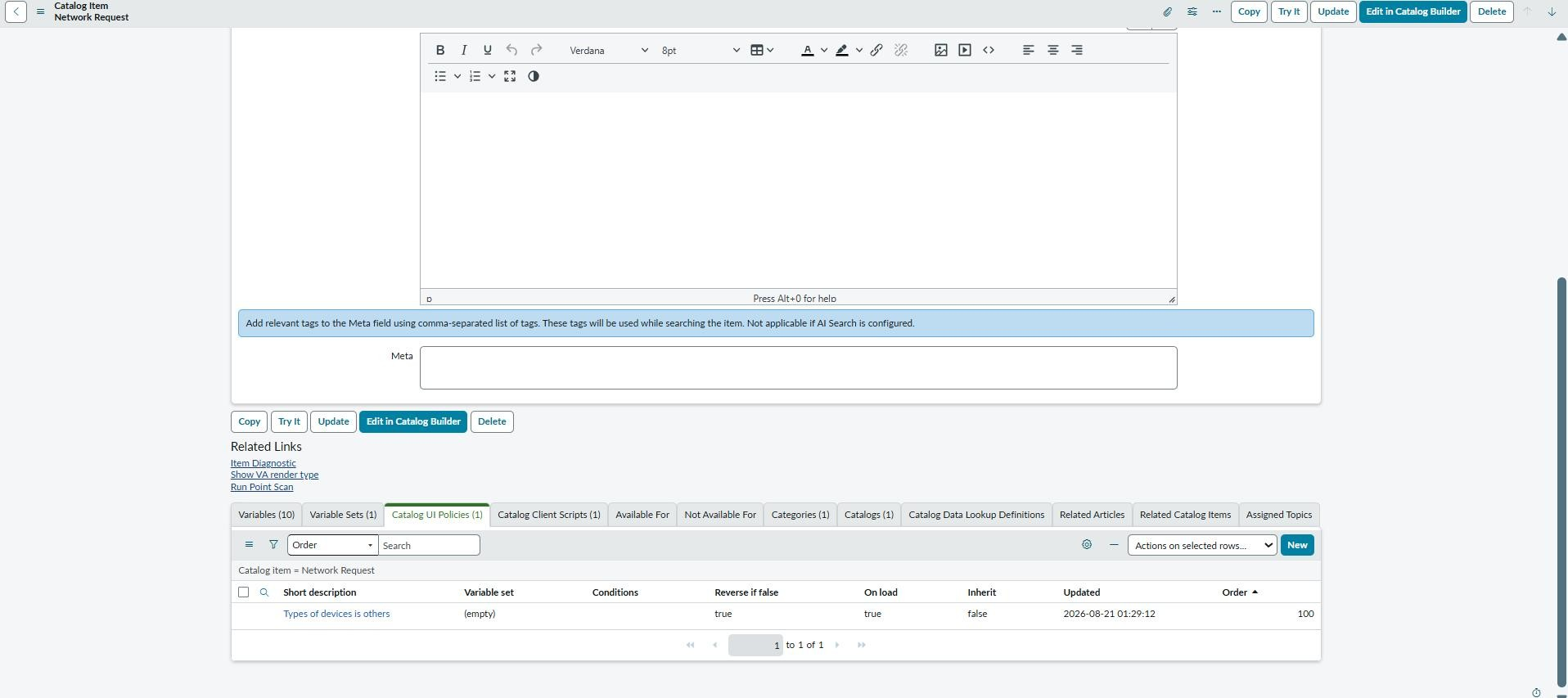
Figure 4.4: Network Request Catalog Item – Variables, UI Policy and Client Script Configuration

5. Phase 4 – Data Migration, Testing & Security
Phase 4 validated the automated workflow, protected the custom data using access controls, tested the request lifecycle, and verified data integrity.
5.1 Automation
The Network Request process was automated using ServiceNow Flow Designer. The flow obtains catalog variables, creates the Network Database record, sends the approval request, handles approved and rejected branches, creates and updates Network Tasks, updates the Network Database status, and sends email notifications.
· Open ServiceNow → All → Flow Designer.
· Open the configured Network Request flow.
· Verify the request trigger and workflow actions.
· Configure the required approval and fulfillment actions.
· Verify that the Network Task is created after approval.
· Save and activate the flow.
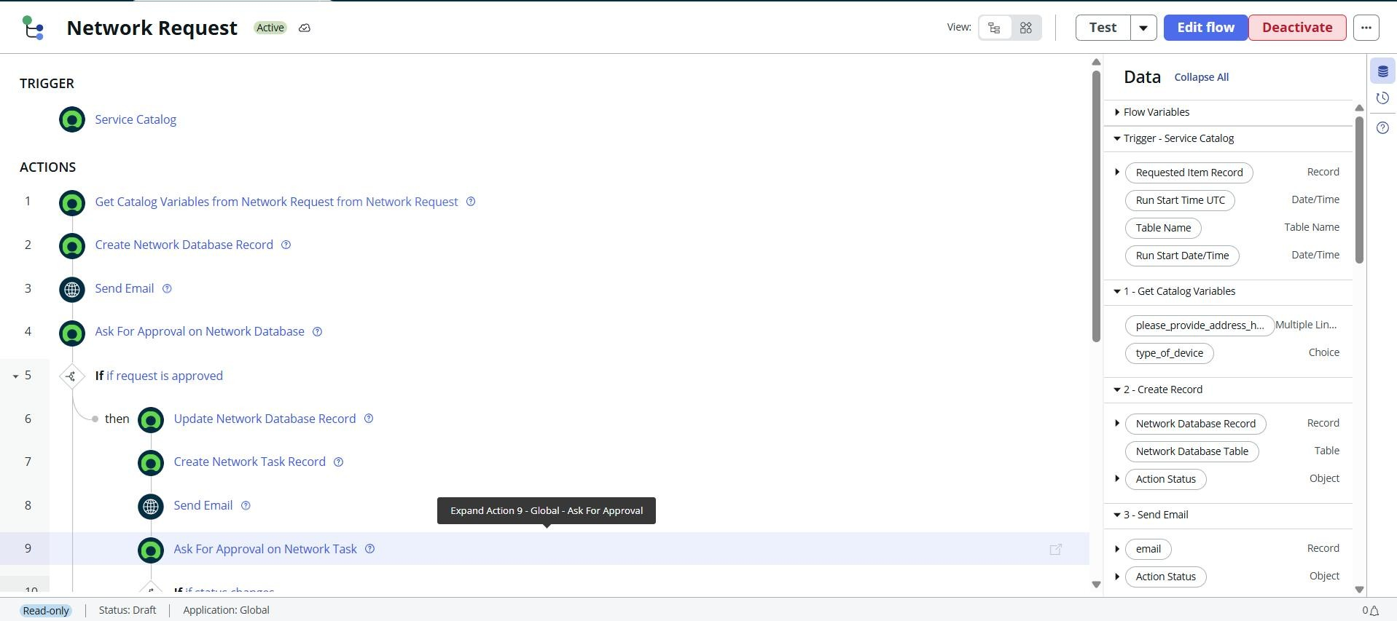
Figure 5.1 – Network Request Flow Designer automation
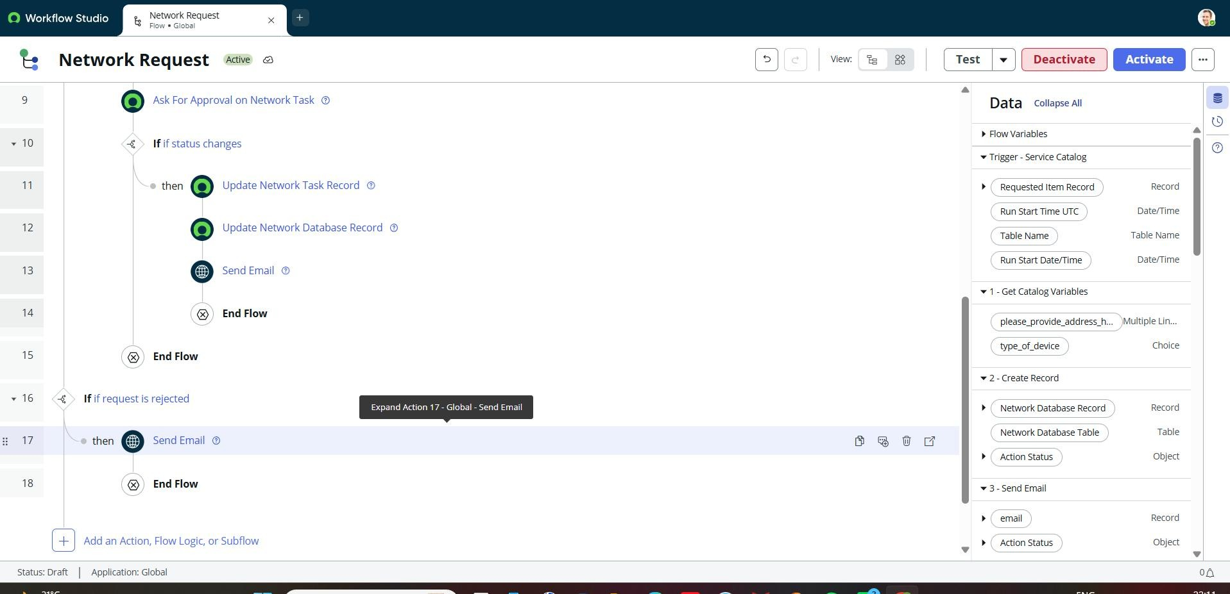
Figure 5.2 – Flow execution/logic showing approval and update branches
5.2 Access Control
Access control was implemented through active ACL configurations. Read, create, write and delete operations are controlled so that access to the custom data is restricted according to the configured rules.
· Navigate to All → System Security → Access Control (ACL).
· Verify access permissions for the Network Request data.
· Ensure only authorized users can create or update requests.
· Verify that approvers and fulfillment users have the required access.
· Save the ACL configuration.
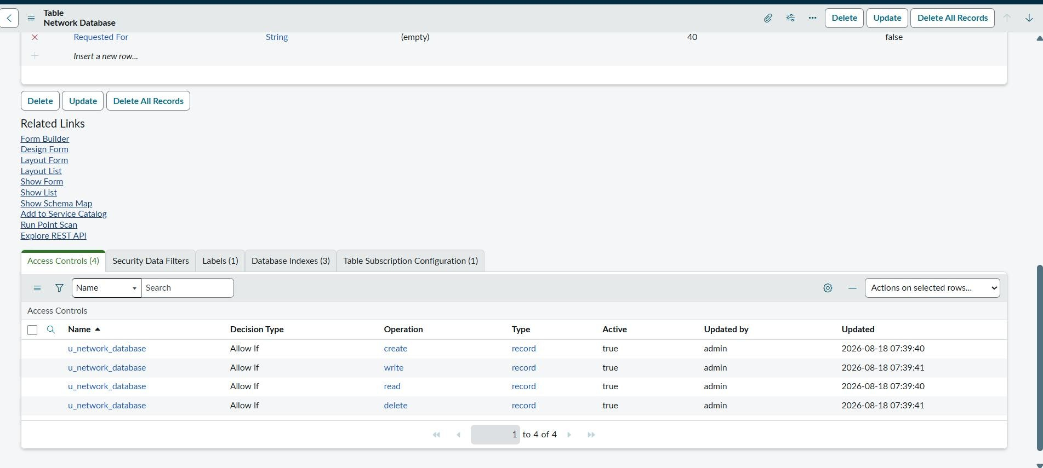
Figure 5.3 – Access Control configuration for the custom table
5.3 QA Testing
End-to-end testing covered request submission, record creation, approval processing, task creation, status updates and email notification. The request submission output confirms successful request creation and generation of a request number. · Open the Network Request catalog item.
· Enter valid request details.
· Submit the request using Order Now.
· Verify that the Request/RITM is generated.
· Verify the approval request is triggered.
· Approve the request.
· Verify that the Network Task is created.
· Complete the task and verify the request status.
· Check that the configured notifications are generated.
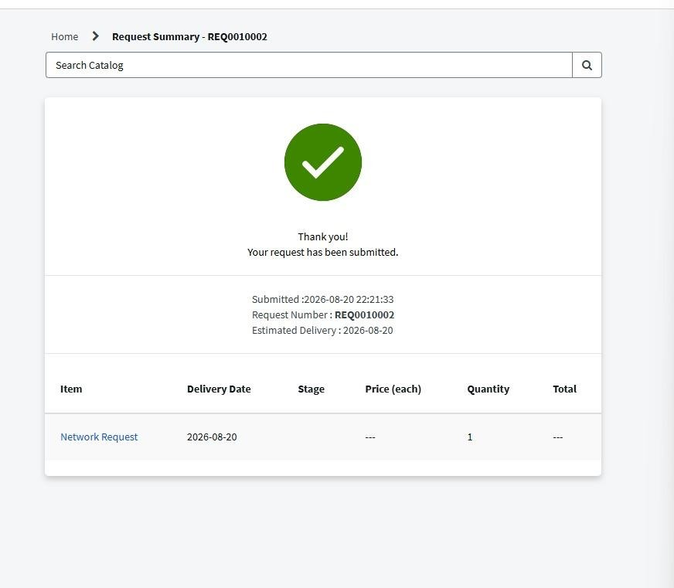
Figure 5.4 – Successful Network Request submission and generated request number
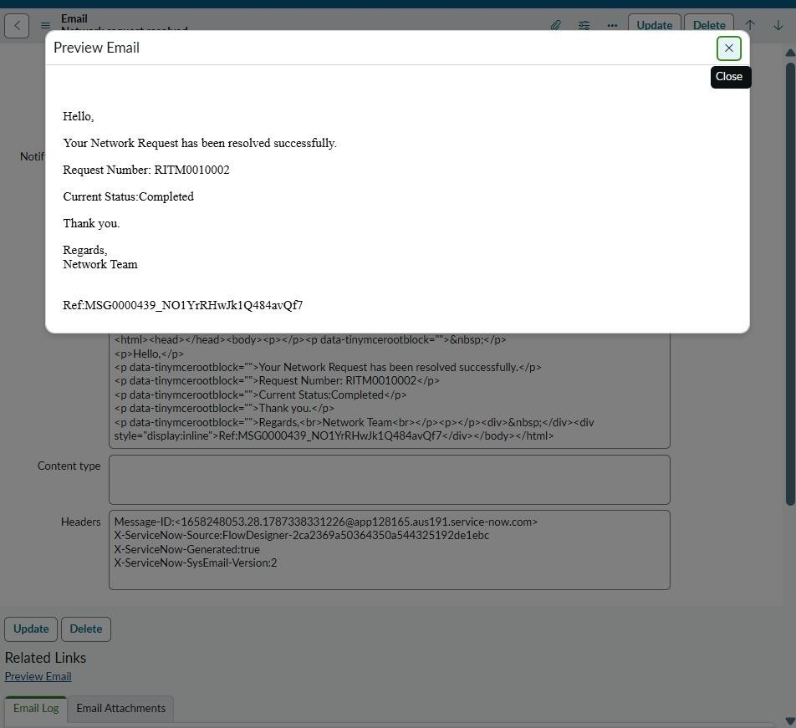
Figure 5.5 – Email notification output
5.4 Data Integrity
Data integrity was supported through mandatory fields, automatic requester population and approval-state checks. The Service Portal form demonstrates required information and automatic Requested For population.
· Open the generated Network Request record.
· Verify that all submitted values are stored correctly.
· Check the relationship between the request, approval and task records.
· Verify that no required information is missing or incorrectly mapped.
· Confirm that the complete request lifecycle is properly recorded.
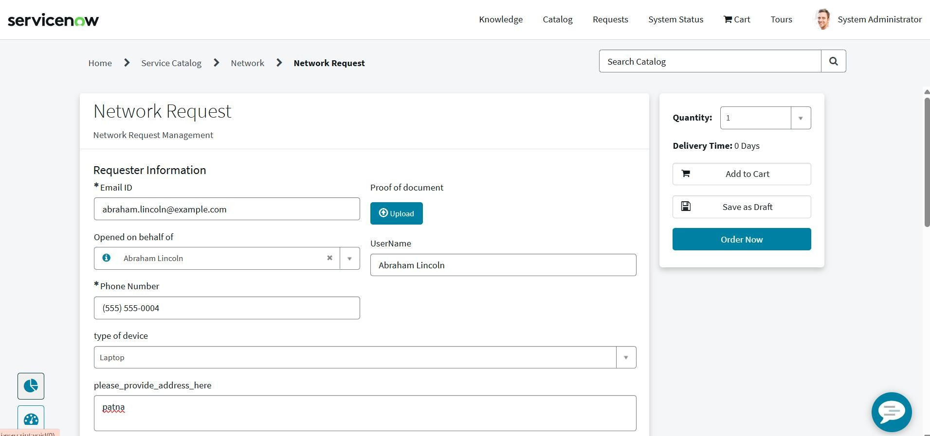
Figure 5.6 – Required fields and requester information
The approval records and workflow outputs provide additional evidence that the request follows the configured approval and status lifecycle.
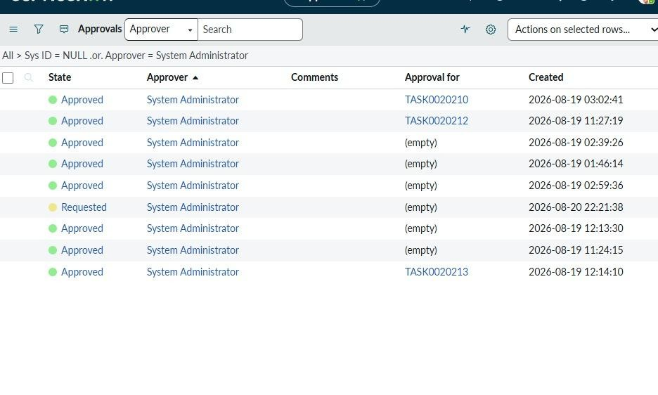
Figure 5.7 – Approval state evidence used for data-integrity validation
6. Phase 5 – Deployment, Documentation & Final Presentation
Phase 5 is the final documentation and presentation stage. The project dashboard defines the following activities for this phase.

Step 1: Troubleshooting
- Review the complete Network Request workflow.
- Check for errors in catalog item, variables, approvals, tasks, and notifications.
- Verify that the configured flow executes correctly.
- Resolve any configuration or validation issues.
- Perform a final end-to-end verification.

Step 2: Adherence to Timelines
- Review the planned project phases and activities.
- Verify that all configured components are completed.
- Ensure testing and deployment activities are completed within the planned timeline.
- Track pending issues and complete the required corrections.

Step 3: Innovation
- Highlight the automation introduced in the Network Request process.
- Show how manual request handling is reduced.
- Demonstrate automated approval and task creation.
- Explain how ServiceNow improves request tracking and visibility.

Step 4: Document Functional Overview
- Document the purpose of the Automated Network Request Management system.
- Explain the complete request lifecycle.
- Describe the Service Catalog, variables, approvals, tasks, and notifications.
- Document the expected user and fulfillment-team workflow.

Step 5: Document Technical Blueprint
- Document the ServiceNow components used.
- Explain the Network Request catalog item.
- Document the custom tables such as Network Database and Network Task.
- Document variables, variable sets, approvals, Flow Designer and related configurations.
- Describe the relationship between request, approval and fulfillment records.

Step 6: Document Setup Manual
- Document the navigation required to access each configuration.
- Provide the steps for creating the catalog item and variables.
- Document table, approval, automation and security configuration.
- Provide the testing procedure.
- Include the required screenshots as configuration evidence.

Step 7: Project Demo Video Planning
- Prepare the demonstration sequence.
- Start with the Network Request catalog item.
- Show request submission and generated records.
- Demonstrate approval and task creation.
- Show the final request status and tracking.

Step 8: Visual Demonstration
- Demonstrate the configured ServiceNow interface.
- Show the Network Request form.
- Show the approval and fulfillment process.
- Demonstrate the final output using actual ServiceNow records.

Step 9: Explanation Clarity
- Explain each configuration in a clear sequence.
- Describe the purpose of every major component.
- Explain how the request moves from submission to completion.
- Keep the final presentation aligned with the implemented system.

Step 10: Realism & Quality
- Demonstrate the actual configured ServiceNow system.
- Verify that the screenshots and records represent the implemented configuration.
- Ensure the workflow produces the expected results.
- Present the final system in a clear and professional manner.

Step 11: Scalability & Future Plan
- Explain how the Network Request solution can be extended to additional network services.
- Add more request types and approval levels when required.
- Extend automation for additional fulfillment activities.
- Improve reporting and monitoring in future versions.

7. End-to-End Functional Output
- User opens the Network Request through the Service Portal.
- Requester and network/device details are entered in the configured request form.
- The user submits the request using Order Now, and ServiceNow generates a Request (REQ) and Requested Item (RITM).
- The submitted request details are recorded in the configured Network Database record.
- An approval request is automatically generated for the configured approver.
- The approver reviews the request and approves or rejects it.
- When the request is approved, a Network Task is automatically created for the fulfillment team.
- The Network Task and Network Database status are updated as the request progresses through the configured workflow.
- After successful completion, the request is marked as completed/resolved, and a completion notification email is generated for the configured recipient.
Final Workflow
Service Portal → Network Request → REQ/RITM → Network Database → Approval → Network Task → Task Completion → Status Update → Email Notification

Figure 7.1 – Request submission form

ig 7.2
-
Reque st
submi
ssion output
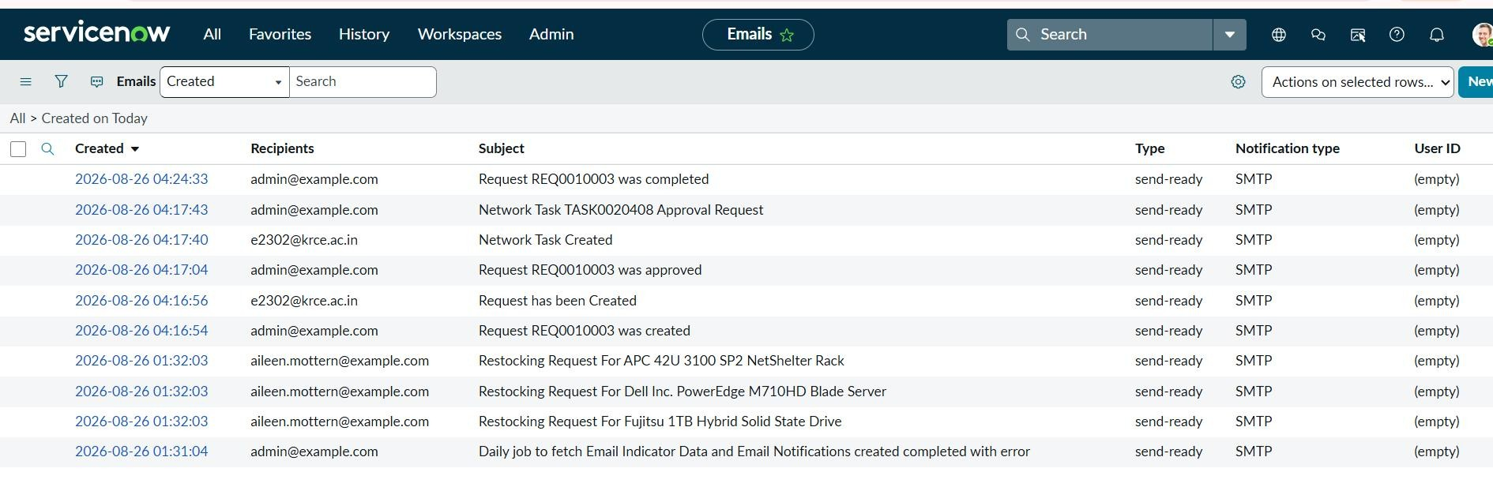
Figure 7.3 – Email output
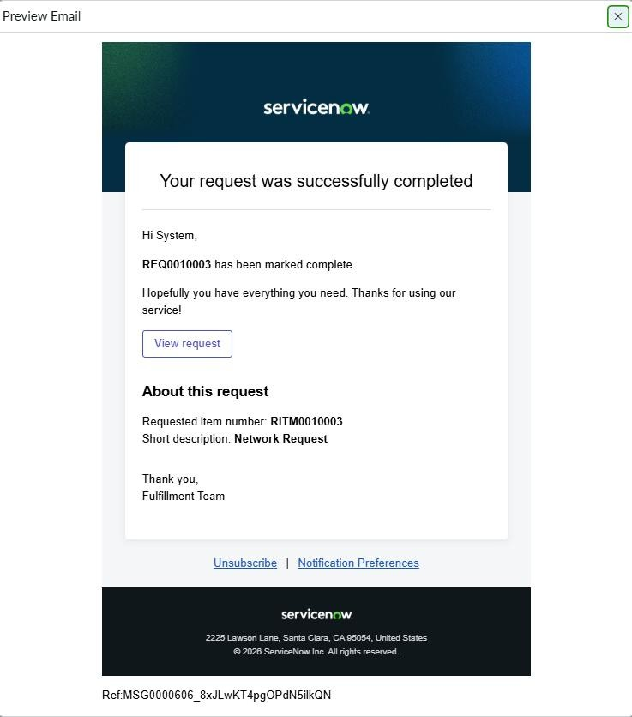
Figure 7.4 – email notification output

8. Project Conclusion
The Automated Network Request Management in ServiceNow project successfully implements a structured and automated process for managing network-related service requests.
The system provides a complete lifecycle:

Request Submission → Request Creation → Approval → Network Task → Fulfillment → Status Update → Notification
The project uses Service Catalog, Catalog Variables, Variable Sets, Custom Tables, Approvals, Flow Designer, Network Tasks, Business Rules, UI Logic, and Notifications to reduce manual effort and improve request tracking.
The final implementation was validated through the end-to-end functional output. The request was successfully submitted, an approval was generated and processed, the fulfillment process was completed, and the requester received a completion notification.

Key Outcomes
- Centralized network request submission
- Structured request information through catalog variables
- Automated approval process
- Automated Network Task creation
- Improved request tracking and visibility
- Reduced manual intervention
- Status updates throughout the request lifecycle
- Completion notification to the requester

